USER’S
MANUAL

Industrial Monitor Converter

(CGA/EGA/MDA/RGB to VGA)

Model: HC1011

Hmwtech Co.,Ltd
Apr 2010

. Features
Hmwtech Co. , Ltd (H.M.W.) in the industrial equipment under long-term maintenance and reconstruction of the monitors& display systems on the lessons learned to gather requirements and feedback of many customers, after many years of development and testing, based on the strength in launch of innovative industrial monitor converter – HC1011, it achieved Industrial video signal(RGB/CGA/VGA to VGA) conversion fully automated operation, will give you the maintenance and replacement of industrial display to bring about affordable price and convenient.

- Feature specifications

Input | Signals | MDA、CGA、EGA、RGB、RGB Sog、RGBS、RGBHV、YPbPr
Input | Interface | 9pin、3pin、6pin、14pin、20pin、25pin
Input | Horizontal Frequency Rate(H) | 12kHz to 40kHz  automatically recognized
Output | Supports | 15pin VGA，Resolution:800*600/60HZ  or custom-resolution
Output | Interface | D-Sub 15 PIN standard VGA port
Power | DC 12V 1.0A

Note:
1.YPbPr = YUV
2.Input Horizontal Frequency Rate 12kHz to 40kHz automatically recognized.
3.Support RGB and YPbPr
4.Support Interlaced Scanning and Line by Line Scanning.
5.Support Vertical Resolution from line200 to line 600 automatically recognized.
6.Support variable Horizontal Resolution automatically recognized。
7.Support RGBHV (separate sync) ,RGBS (composite sync), automatically recognized
8.Output resolution: 800*600/60Hz standard VGA or custom-resolution.

3. Interface Specification

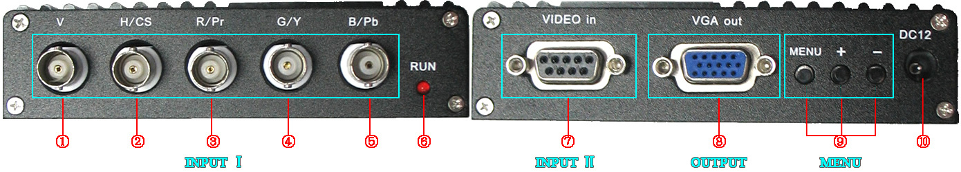

Item | Spec. | Remarks
① V | To connect V interface of the input device | Input Channel Ⅰ
② H/CS | To connect H(CS) interface of the input device | Input Channel Ⅰ
③ R/Pr | Red signal input/ Pr signal input | Input Channel Ⅰ
④ G/Y | Green signal input/ YPBPR -Y signal input | Input Channel Ⅰ
⑤ B/Pb | Blue Signal input/YPBPR -Pb signal input | Input Channel Ⅰ
⑥ RUN | Running Status Indicator
⑦ VIDEO in | To connect 9-pin interface of the input device | Input Channel Ⅱ
⑧ VGA out | Standard sub-15p VGA female interface | VGA Output
⑨ MENU | Use to adjust screen /programming
⑩ DC12 | Power input DC12V, 1A
Note: Input Channel Ⅰ, Input Channel Ⅱ, you can choose one of them

4. Definition for I/O interface

Table 4.1 Definition for Input Channel Ⅱ:
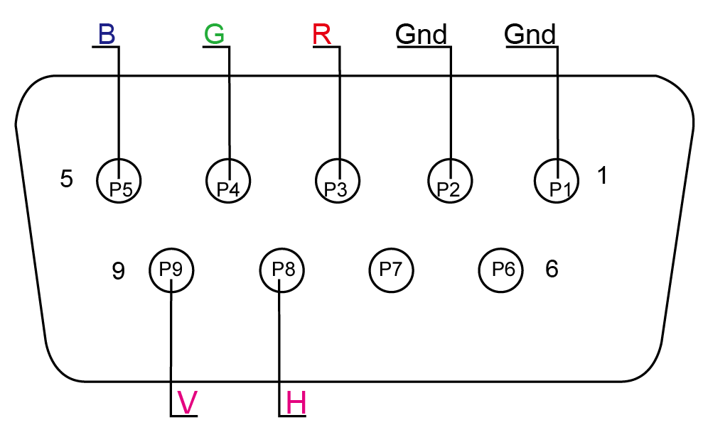
PIN | Input Signal
p1(GND) | Connect to the ground
p2(GND) | Connect to the ground
P3(R) | connect R(ed) interface of the input device
P4(G) | connect G(reen) interface of the input device
P5(B) | connect B(lue) interface of the input device
P6 | Undefined(null)
P7 | Undefined(null)
P8(H) | connect H(CS) interface of the input device
P9(V) | connect V interface of the input device

Figure 4.1 Definition for Input Channel Ⅱ

Table 4.2 Definition for Input Channel Ⅰ
BNC | Input Signal | Connection image
Pb、Y、Pr | YPbPr input signal (right image)  Interface: three BNC slot, connected to the corresponding Pb, Y, Pr interface, then Y monochrome port. | 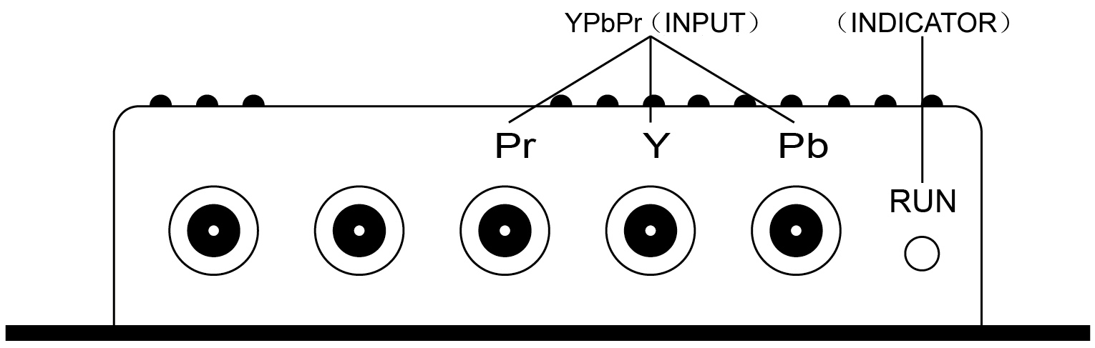  Figure 4.2 Analog 3BNC (YPBPR) Input.
R、G、B | RGB Sog input signal (right image)  Interface: three BNC slot, connected to the corresponding R, G, B slot, then G monochrome port. | 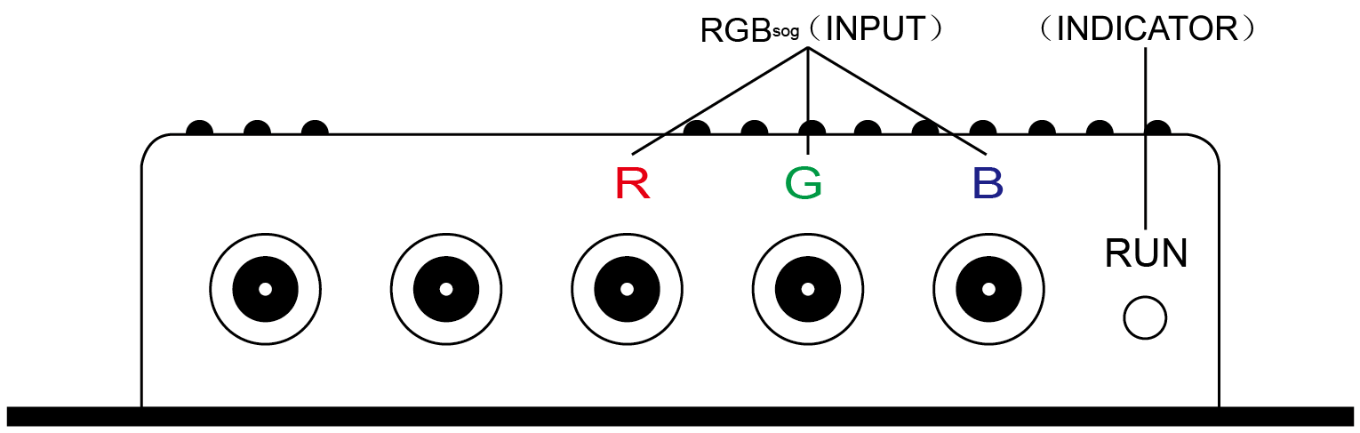  Figure 4.3 Analog 3BNC (RGB Sog) Input.
R、G、B、S | RGBS CS Composite Sync (right image)  Interfaces: 4 BNC slot, connected to the corresponding R, G, B, S I, monochrome then G, S I | 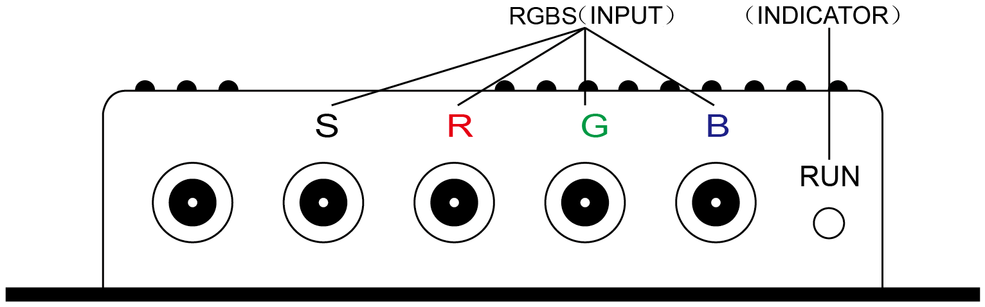  Figure 4.4 Analog 4BNC (RGBS CS) Input.
R、G、B、H、V | RGBHV separate sync (right image)  Interface: 5 BNC port, connected to the corresponding R, G, B, H, V I, monochrome then G, H, V I | 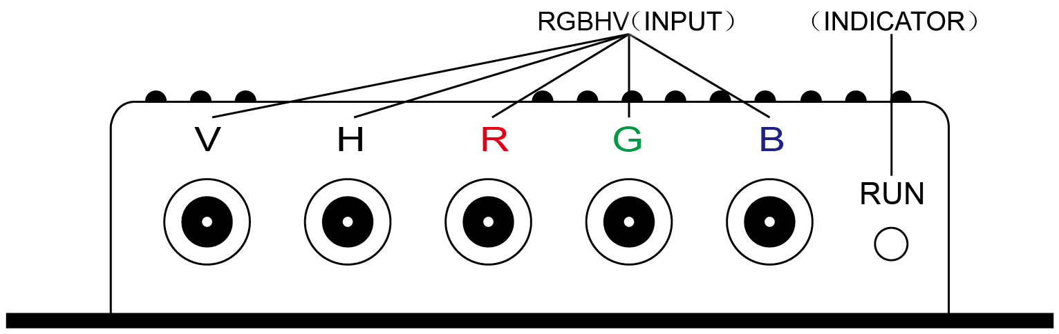  Figure 4.5 Analog 5BNC (RGBHV) Input.

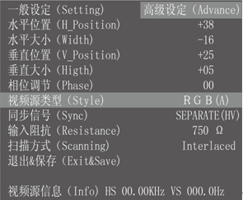
5. Operation Menu
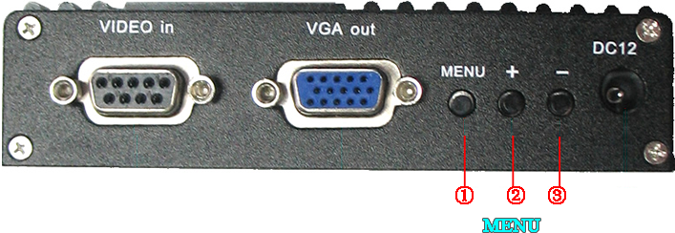

Item | Spec.
①MENU | -press it to enter into OSD menu  -click it once to select and click again to exit the current line
② “+” | -click it to move the cursor up  -click it to add the value
③ “-“ | -click it to move the cursor down  -click it to deduct the value

6. Accessories& Details

Table 6.1 Accessories list
Item | QTY | Remarks
User’s Manual | 1 | English
Power Adaptor | 1 | DC12V,1A
half 9pin cable | 1
9pin M-F cable | 2 | 1 Male + 1 Female

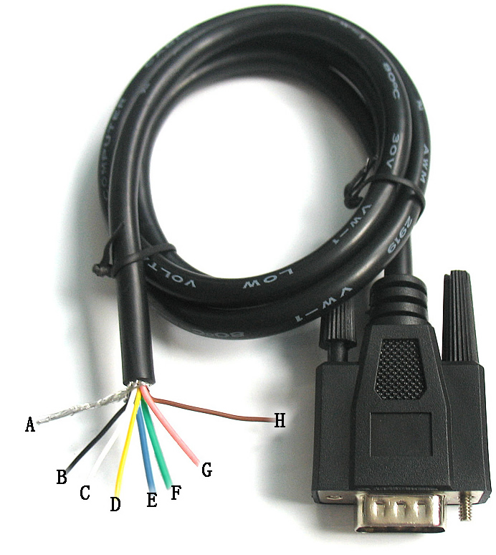
Table 6.2 Details of half 9Pin connector
Name | Wire color | Signal
A | Silver web | Shield
B | Black wire | Ground(GND)
C | White wire | Vertical Frequency Rate(V)
D | Orange wire | Horizontal Frequency Rate(H)
E | Blue wire | Blue(B)
F | Green wire | Green(G)
G | Red wire | Red(R)
H | Brown wire | Undefined(null)

Figure 6.2 Half 9pin cable

If you have any more queries, please contact
Mr. Sambob Wu
Tel/Fax:+86 755-28700114
Cell: +86 135 1046 8916
Email:sam.bob.wu@harmonywolrd.com
Skype: abbula3026
MSN: woll-mart@hotmail.com

